[1]

CmpE 124 Lab 2: Signal Generator Test

Anahit Sarao, 008435583 , CmpE 124 Fall 2016, Lab Section 8

*Abstract*—Lab two’s report is a breakdown and analysis of the purpose for lab two which was to create a clock- counter circuit that was to act as a signal generator for testing and observing how NAND, NOR and XOR gates function.

# INTRODUCTION

The clock-counter circuit is a 4 bit binary counter that counts from zero till binary number 15. By using the 74LS163 as the counter the circuit can be used as a signal-generator allowing additional testing with 74LS00, 74LS02, and 74LS86 gates. The gate characteristics can be observed by using LogicWorks.

# Design methodology

## Parts List

* 1x 74LS00
* 1x 74LS02
* 1x 74LS86
* 1x 74LS163

## Truth Tables

|  |  |  |
| --- | --- | --- |
| Truth Table For 74LS00 NAND Gate | | |
| A | B | Y |
| 0 | 0 | 1 |
| 0 | 1 | 1 |
| 1 | 0 | 1 |
| 1 | 1 | 0 |
|  |  |  |
| Truth Table For 74LS02 NOR Gate | | |
| A | B | Y |
| 0 | 0 | 1 |
| 0 | 1 | 0 |
| 1 | 0 | 0 |
| 1 | 1 | 0 |
|  |  |  |
| Truth Table For 74LS86 EOR Gate | | |
| A | B | Y |
| 0 | 0 | 0 |
| 0 | 1 | 1 |
| 1 | 0 | 1 |
| 1 | 1 | 0 |

## Original and Derived Equations

Equation for 74LS00 NAND Gate

$$Y=\overline{A}*\overline{B}$$

Equation for 74LS02 NOR Gate $Y=\overline{A+B}$

Equation for 74LS86 EOR Gate

$$Y=A⨁B$$

## Schematics

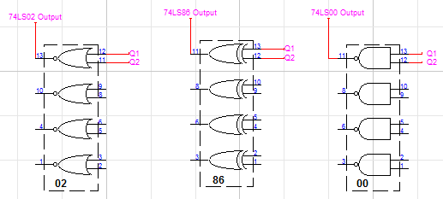The schematic shows three gate outputs labeled as 74LSXX Output and shows the standard output of the 74LS163 labelled as Q1, Q2, Q3, Q4. The clock is an input to the CLK pin, while the RCO is labeled as an output. The label Fin1 is a branch label that provides appropriate signals to LOAD, P, T, while the CLR pin is controlled by a binary switch to allow manual reset during simulation.

The schematic above shows the counter circuit connected to 3 different gates.

# testing procedures

1. Assemble the counter circuit.
2. Observe behavior of the counter circuit.
3. Connect outputs Q0 and Q1 to each gate:
4. 74LS00
5. 74LS02
6. 74LS86
7. Observe and collect results.

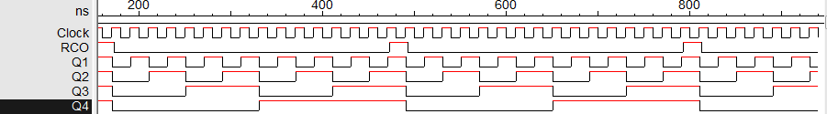The Clock being reference waveform is on top, under it the RCO which shows reset at the end of each clock period. The outputs Q1, Q2, Q3, and Q4 are grouped and are shown as 16bit hexadecimal.

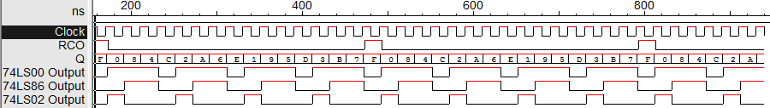The three gate outputs are shown to easily observe the outputs.

# testing results

Picture from the testing procedures show waveforms of the 74LS00 output with the clock, clock and the RCO as reference. The outputs of the 74LS86 and L74LS02 are also shown below the clock and RCO. The first half of the clock cycle is on the positive x-axis and the negative x-axis shows the second half of the clock cycle.

Comparing the waveforms within one clock period shows that they match for all three gates. Each gate has eight transitions from the either high to low or vice versa. Also each gate follows the provided expressions and table, for example the 74LS02 is only High when the counter is at binary zero, four, eight, and twelve which is when the LSB and succeeding bit are both 0. This shows that the tables and waveforms match the expression for each gate.

# Conclusion

By creating a binary counter the three gates were observed on LogicWorks. The waveforms were correct for each component. Each rising edge form the clock is a stage, during the rising edge the output are either HIGH or LOW respective to the binary count. At different stages each of the three gates were triggered as the relating expression was true.

For observations of the each clock period which is fifteen cycles from HIGH and LOW a reference was needed to observe when binary the count had reset at binary zero. The reference was the Ripple Carry Output which is the triggered once a carry bit is generated. This would be at fifteen when the count needs to reset which is why a spike is caused in the RCO. Hence to look at one full clock period the RCO was chosen as reference as looking from RCO spike to the next would show the full count to fifteen.

By comparing and observing the gates through LogicWorks the functionality and purpose was much clear. As the truth tables do not clearly tell how each gate works but only tell when the gate will work. However some questions remain unanswered such as what is the actual use of such gates and how they are implementing in circuitry. Overall the execution of the lab on LogicWorks was success as the results match to the expected.

# appendices and references

Özemek, Haluk. (2014, Aug 14). 124_Labs [Online]. Available: https://sjsu.instructure.com/courses/1142847/files

1. Anahit Sarao, indianvip60@gmail.com